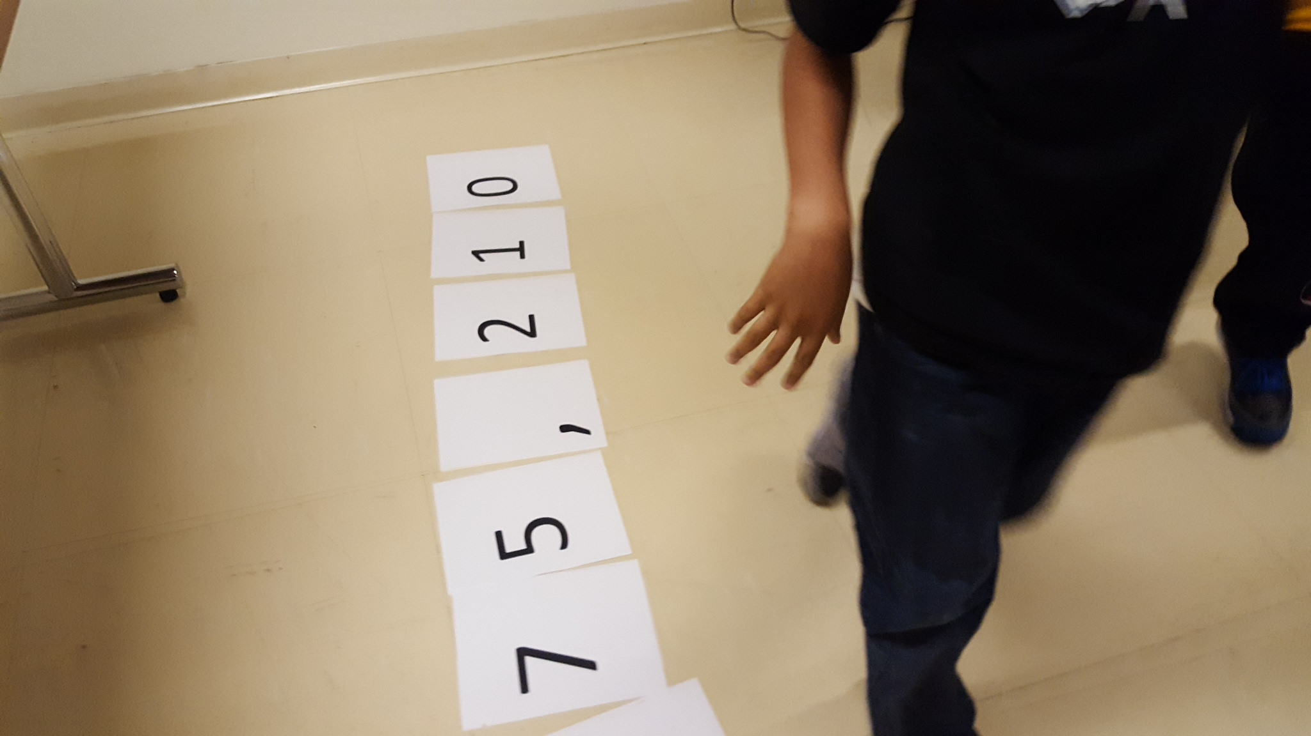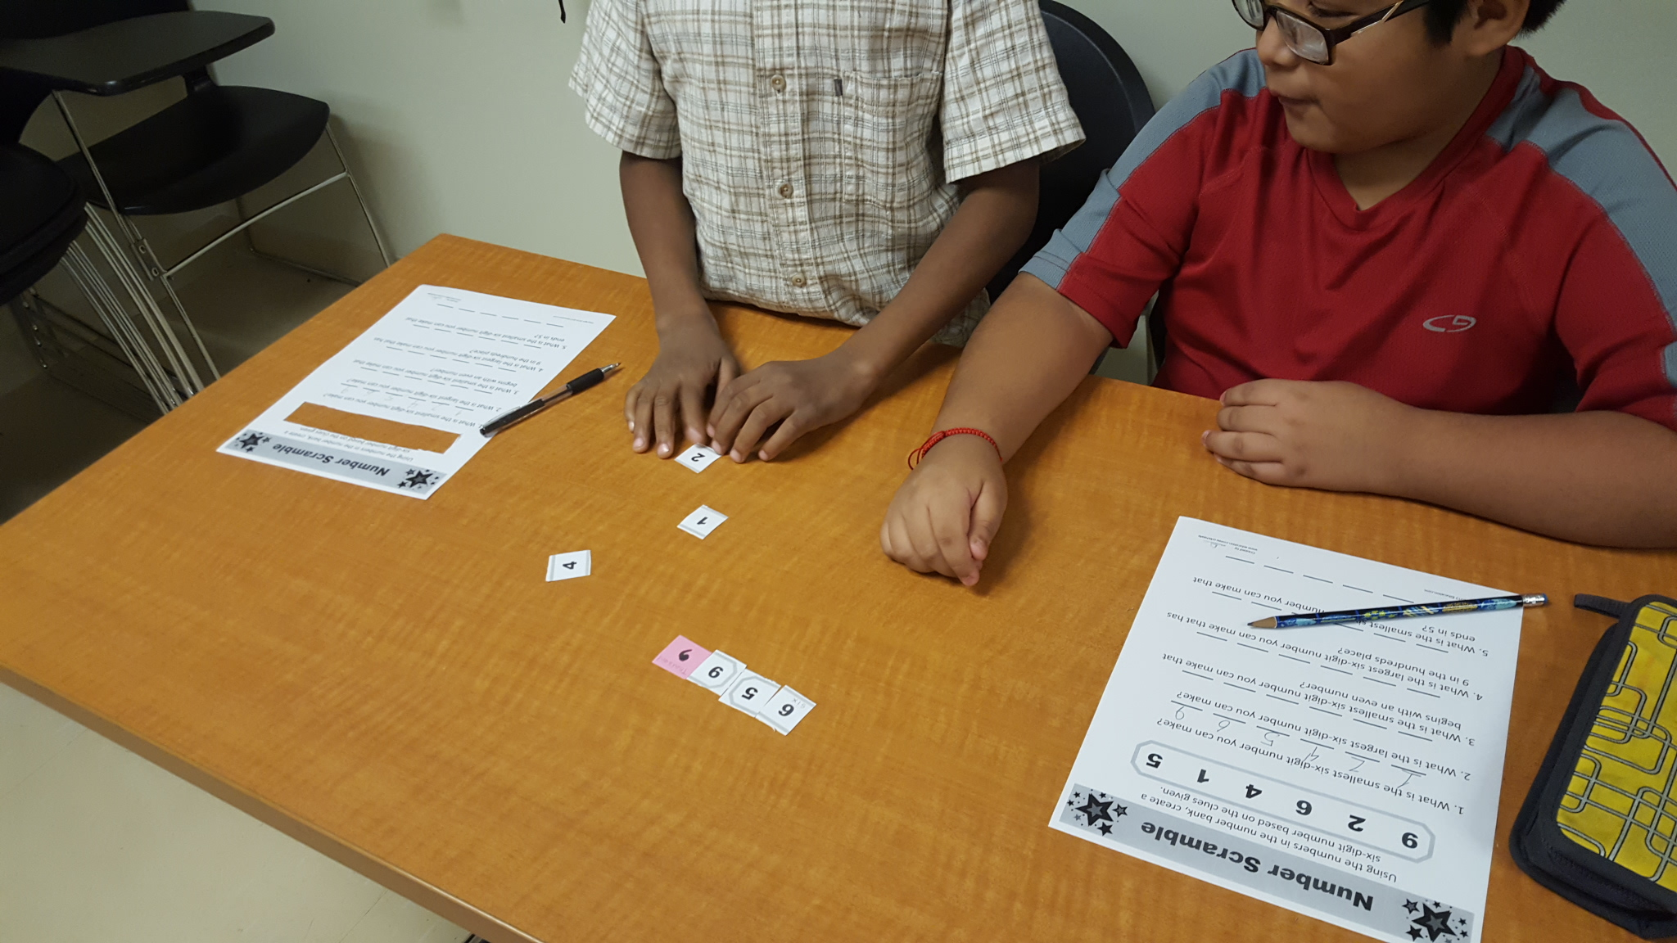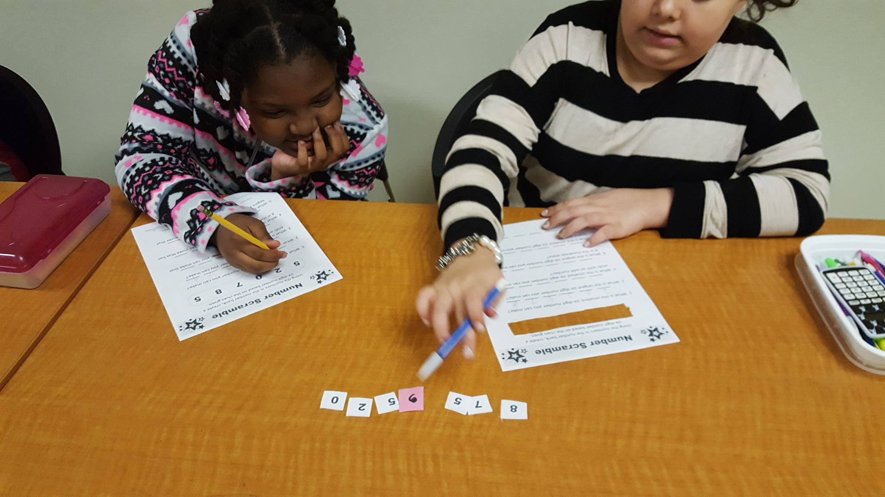

* Please download the media consent form on the resources tab of our classroom site and send it to school this week.

* Also download the PE logs and PE requirements file on the resources tab to begin keeping track of your scholar’s physical activities! Go for walks and jogs, play a sport, attend a dance class!

**PARENT HOMEWORK**

**Place Value**

**Fun!**

Last week in the learning center we had a great time with math activities that reinforced our place value skills. Students are working so well together and I couldn’t be more proud! Continue to help me encourage our scholars weekly and remind them to do their very best each time we meet.

*OUR VIRTUAL CLASSROOM*

Some learning coaches have reached out to me about the workload of their scholars. Good news! You scholar’s schedules can be adjusted. If you have not adjusted the schedule, you are working on a default schedule. Math and Language Arts should be scheduled daily. Also Science, History, Art and Health should be scheduled no more than 2 days a week. Go to ***PLAN***tab on OLS home page then ***SCHEDULE SETUP.***

**CLASS CONNECT WILL BEGIN**

**September 29, 2016**

Scholars need to come to the learning center prepared to work! Make sure they are bringing supplies!

**COMMON CORE STANDARD**

Reading

RI 4.2

Determine the main idea of a text and explain how it is supported by key details; summarize the text.

Math

4.NBT. A1

Recognize that in a multi-digit whole number, a digit in one place represents ten times what it represents in the place to its right.

We are still testing for NWEA this week! Show what you know in MATH!

# What are we learning this week?

WEEK 3 SY 2016-17

ISSUE 2

Weekly News

# We’re busy with math and reading!

CVCS GRADE 4 – MS. BUTLER

### the

**Back to School Skate**

Please join us for our annual Back

to School Skate on **Friday,**

**September 30, 2016** at the

Dr. Martin Luther King Jr. Park & Family Entertainment Center 1219 W. 76th Street.

*Pay $5 ahead of time in the main office, this includes admission and skate rental.*

*Pay at the door the day of the party, the cost will be $5.50 for admission and skate rental.*

*Learning Coaches and siblings who are not skating are not required to pay. Please bring exact change.*

Please note that Learning Coaches and siblings are not required to pay.

Are you a student in 4-8th Grades that loves to read? Do you like to talk about books? Do you like a little friendly competition? Then consider joining the Chicago Virtual Charter School’s CPS Battle of the Books team!

You are required to read 4 books (by March 1st) from a pre-determined list, write 10 questions about each book read, and regularly attend virtual Battle of the Books meetings. Six students from 4-6th Grades, and six students from 7th and 8th Grades will be selected to represent CVCS at the city wide competition next spring.

Please email Kary Batchelder, teacher, by Friday, September 23rd if you are interested in joining the team, and for further information. Book lists and meeting information will be forwarded to those who express interest in the team.

MOST students have experience using these two web-based learning sites. Please be patient with me as I work on getting accounts set up. I will let you know when assignments are created to begin.

STUDY ISLAND AND MOBY MAX

We are fortunate enough to have a great AC system to keep us cool at the learning center. It’s so good that some of us have felt too chilly in the small classroom! PLEASE send a sweatshirt or small jacket in your child’s back pack as it is difficult to concentrate and do your best thinking if you are uncomfortable.

# Battle of the Books

**FRIENDLY**

**REMINDERS**